**20BCS042 | MOHD ADIL**

**PROGRAM:3 -> SHORTEST JOB FIRST NON-PREEMPTIVE SCHEDULING ALGORITHM**

#include<iostream>

#include<vector>

using namespace std;

struct Process{

    char Pname[3];

    int arvlTime;

    int brstTime;

    int cmplTime;

    int wtngTime;

    int tartTime;

    int respTime;

};

struct priorityQ{

    Process pr;

    priorityQ *next;

};

priorityQ *push(priorityQ *front, Process pSample, char b){

    priorityQ *node = new priorityQ;

    node->pr = pSample;

    node->next=NULL;

//means push according to burst Time

    if(b=='b'){

        if(front==NULL){

            front=node;

        }

        else if(front->pr.brstTime > pSample.brstTime){

            node->next=front;

            front=node;

        }

        else{

            priorityQ *tmp=front;

            while (tmp->next!=NULL && tmp->next->pr.brstTime < pSample.brstTime){

                tmp=tmp->next;

            }

            node->next=tmp->next;

            tmp->next=node;

        }

    }

//otherwise push accoring to arrival time

    else{

        if(front==NULL){

            front=node;

        }

        else if(front->pr.arvlTime > pSample.arvlTime){

            node->next=front;

            front=node;

        }

        else{

            priorityQ *tmp=front;

            while (tmp->next!=NULL && tmp->next->pr.arvlTime < pSample.arvlTime){

                tmp=tmp->next;

            }

            node->next=tmp->next;

            tmp->next=node;

        }

    }

    return front;

}

priorityQ *pop(priorityQ *front){

    front=front->next;

    return front;

}

Process top(priorityQ *front){

    return front->pr;

}

bool empty(priorityQ *front){

    return (front==NULL);

}

//ans vector

vector<Process> v;

int n;

float avgc, avgw, avgt;

void SJF(priorityQ *pq1){

    int cmpt = top(pq1).brstTime;

    v.push_back(top(pq1));

    pq1 = pop(pq1);

    priorityQ *pq2=NULL;

    while(!empty(pq1)){

        while(!empty(pq1) && top(pq1).arvlTime < cmpt){

            pq2 = push(pq2, top(pq1), 'b');

            pq1 = pop(pq1);

        }

        cmpt += top(pq2).brstTime;

        v.push_back(top(pq2));

        pq2 = pop(pq2);

    }

    while(!empty(pq2)){

        v.push_back(top(pq2));

        pq2 = pop(pq2);

    }

}

void calculateTimes(){

    v.front().wtngTime=0;

    v.front().cmplTime = v.front().brstTime;

    float sumc=0, sumw=0, sumt=0;

    //calculating completion time

    int prv = v.front().cmplTime;

    sumc += prv;

    for(int i=1; i<n; i++){

        v[i].cmplTime = prv + v[i].brstTime;

        prv = v[i].cmplTime;

        sumc += v[i].cmplTime;

    }

    //calculating waiting time

    prv = v.front().cmplTime;

    for(int i=1; i<n; i++){

        v[i].wtngTime = prv - v[i].arvlTime;

        prv = v[i].cmplTime;

        sumw += v[i].wtngTime;

    }

    //calculating turn around time

    for(int i=0; i<n; i++){

        v[i].tartTime = v[i].brstTime + v[i].wtngTime;

        sumt += v[i].tartTime;

    }

    //calculating avg(s) time

    avgc = sumc/n;

    avgw = sumw/n;

    avgt = sumt/n;

}

void display(){

    cout<<"\n\nDisplaying the table :- ";

    cout<<"\n\n+--------------+------------+--------------+-----------------+--------------+-----------------+---------------+";

    cout<<"\n| Process name | Burst Time | Arrival Time | Completion Time | Waiting Time | TurnAround Time | Response Time |";

    cout<<"\n+--------------+------------+--------------+-----------------+--------------+-----------------+---------------+";

    for(auto i:v){

        printf("\n|      %s      |    %2d      |      %2d      |        %2d       |      %2d      |      %2d         |      %2d       |"

               ,i.Pname, i.brstTime, i.arvlTime, i.cmplTime, i.wtngTime, i.tartTime, i.wtngTime);

    cout<<"\n+--------------+------------+--------------+-----------------+--------------+-----------------+---------------+";

    }

    cout<<"\n\n";

    printf("\nAverage Completion time : %.2fns", avgc);

    printf("\nAverage Waiting time : %.2fns", avgw);

    printf("\nAverage TurnAround time : %.2fns", avgt);

    printf("\nAverage Response time : %.2fns", avgw);

}

void printGantt(){

    cout<<"\n\nGantt Chart : ";

    cout<<"\n\n+";

    for(auto p:v){

        for(int i=0; i<2*p.brstTime; i++){

            cout<<"-";

        }

        cout<<"+";

    }

    cout<<"\n|";

    for(auto p:v){

        for(int i=0; i<p.brstTime-1; i++){

            cout<<" ";

        }

        cout<<p.Pname;

        for(int i=0; i<p.brstTime-1; i++){

            cout<<" ";

        }

        cout<<"|";

    }

    cout<<"\n+";

    for(auto p:v){

        for(int i=0; i<2*p.brstTime; i++){

            cout<<"-";

        }

        cout<<"+";

    }

    cout<<"\n0";

    for(auto p:v){

        for(int i=0; i<2*p.brstTime-1; i++){

            cout<<" ";

        }

        printf("%2d", p.cmplTime);

    }

    cout<<"\n\n";

}

int main(){

    priorityQ *pq1=NULL;

    cout<<"Enter the no of the Processes : ";

    cin>>n;

    for(int i=0; i<n; i++){

        struct Process p;

        cout<<"Enter Process "<<i+1<<" name, its burst Time and Arrival Time : ";

        cin>>p.Pname>>p.brstTime>>p.arvlTime;

        pq1 = push(pq1, p, 'a');

    }

    //sort according to arrival time + burst Time :

    SJF(pq1);

    calculateTimes();

    display();

    printGantt();

    return 0;

}

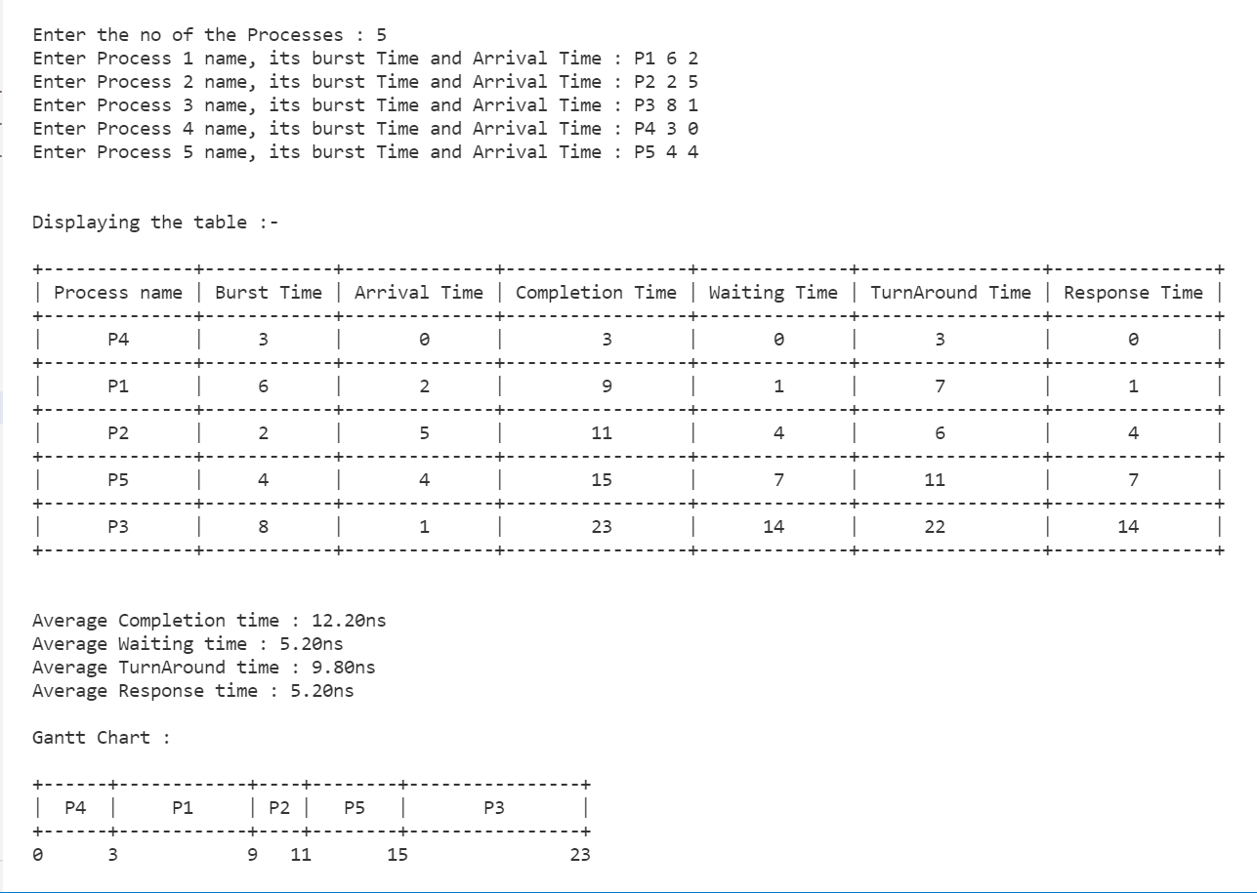**OUTPUT:**